👋 Welcome to the TV Dashboard Automation Course
<h2>🔧 What You&#39;ll Need Before You Start</h2>

<ul>
<li>A <strong>ServiceTitan</strong> account with access to Reports</li>
<li>A <strong>Gmail</strong> account (preferably connected to Zapier)</li>
<li>A <a href="https://zapier.com" target="_blank">Zapier</a> account</li>
<li><strong>Google Drive</strong> (Google Sheets access)</li>
<li><strong>Looker Studio</strong> (formerly Google Data Studio)</li>
<li>Basic familiarity with the tools above (don&rsquo;t worry &mdash; I&rsquo;ll walk you through everything!)</li>
</ul>
<hr>

<h2>📦 What You&rsquo;ll Build</h2>

<p>You&rsquo;re going to build an automated, TV dashboard that updates multiple times per day using live job data from ServiceTitan &mdash; with <strong>zero manual effort</strong> once it&#39;s set up.</p>
<hr>

<h2>🚀 Course Overview</h2>

<ol>
<li><strong>Create and Schedule the ServiceTitan Report</strong></li>
<li><strong>Create a Gmail Filter &amp; Label</strong></li>
<li><strong>Build a Zap in Zapier to Detect New Reports</strong></li>
<li><strong>Feed the Report into Google Sheets Automatically</strong></li>
<li><strong>Build Your TV Dashboard in Looker Studio</strong></li>
<li><strong>Style and Customize Key Metrics</strong></li>
</ol>
<hr>

<h2>✅ What You&#39;ll Walk Away With</h2>

<ul>
<li>A <strong>fully automated dashboard</strong> on your office TV</li>
<li>Instant visibility into job data, revenue, leads, and more</li>
<li>A repeatable system you can use for other reports</li>
<li><strong>Less time digging for data, more time acting on it</strong></li>
</ul>

<p>Ready? Let&rsquo;s dive in.</p>
🚀 Course Overview
Create and Schedule the ServiceTitan Report
Create a Gmail Filter & Label
Build a Zap in Zapier to Detect New Reports
Feed the Report into Google Sheets Automatically
Build Your TV Dashboard in Looker Studio
Style and Customize Key Metrics
✅ What You'll Walk Away With
A fully automated dashboard on your office TV
Instant visibility into job data, revenue, leads, and more
A repeatable system you can use for other reports
Less time digging for data, more time acting on it
Ready? Let’s dive in.

📊 Before You Begin: A Quick Note About Dashboarding with ServiceTitan

There are many ways to connect to ServiceTitan data and build dashboards — some involve APIs, middleware, or advanced reporting tools.
What you're about to learn is the lowest-code, most DIY-friendly method available.
It uses tools you likely already have — Gmail, Google Sheets, Zapier, and Looker Studio.
💡 Don’t get discouraged if it feels like a lot at first. Once you get this initial setup dialed in, adding new reports and dashboards becomes fast and easy.
You’ve got this — and I’ll walk you through every step.
Let’s get started!

➡️ Workflow Overview

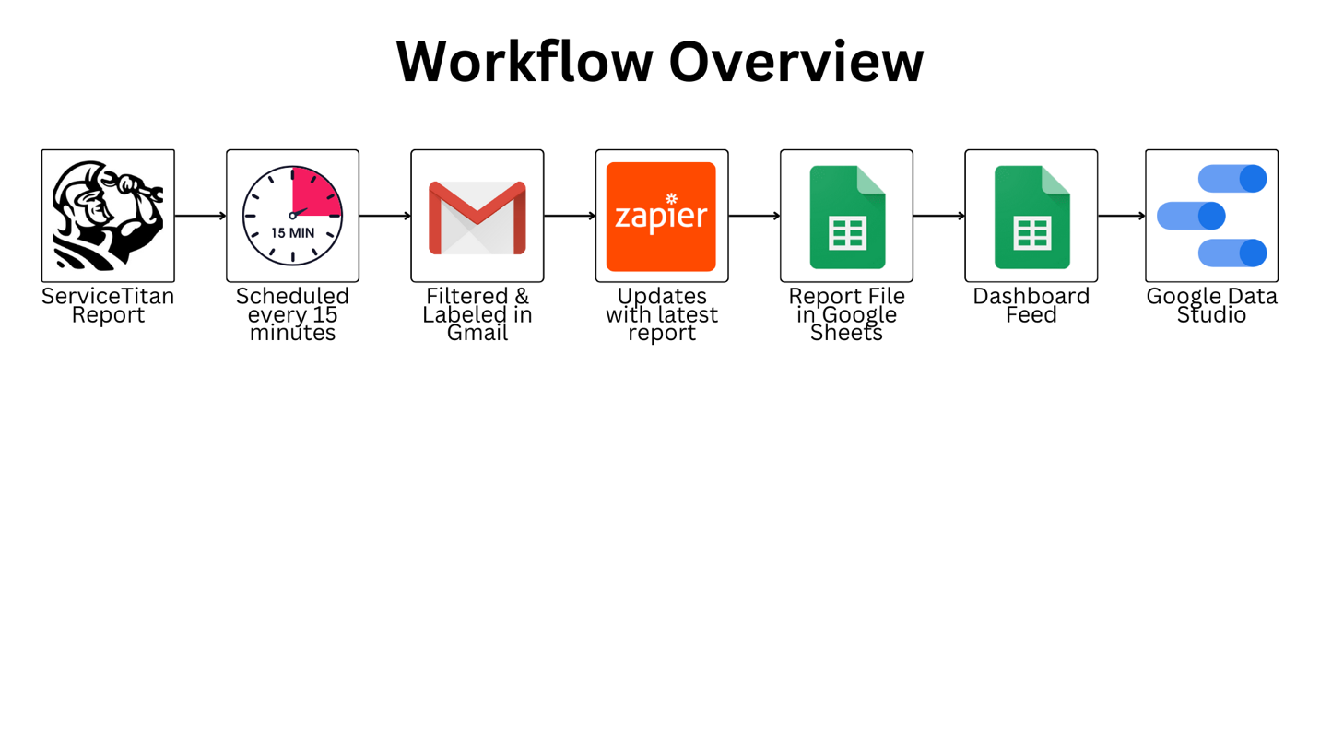

🗓️ Create & Schedule your ServiceTitan Report
<p style="text-align: center;"><strong>This walkthrough guide allows you to see each individual click💥</strong></p>

<p>
<iframe src="https://app.tango.us/app/embed/5de81e74-ffd1-4685-a4c5-39339d609df2" style="width: 100%; height: 640px; border: none;" sandbox="allow-scripts allow-top-navigation-by-user-activation allow-popups allow-same-origin" title="1) Create and Schedule the ServiceTitan Report" webkitallowfullscreen="" mozallowfullscreen="" allowfullscreen=""> </iframe>
</p>

🗳️ Import the ServiceTitan Report to Google Sheets
<p>
<iframe src="https://app.tango.us/app/embed/ee01e776-ca12-4b98-ab34-401b82b78246" style="width: 100%; height: 640px; border: none;" sandbox="allow-scripts allow-top-navigation-by-user-activation allow-popups allow-same-origin" title="2) Import the ServiceTitan Report to Google Sheets" webkitallowfullscreen="" mozallowfullscreen="" allowfullscreen=""> </iframe>
</p>
📧 Creating a Filter/Label in Gmail

<p>
<iframe src="https://app.tango.us/app/embed/b57aa3bf-df61-4ea7-bd4b-747dc417ac83" style="width: 100%; height: 640px; border: none;" sandbox="allow-scripts allow-top-navigation-by-user-activation allow-popups allow-same-origin" title="3) Creating a Filter/Label in Gmail" webkitallowfullscreen="" mozallowfullscreen="" allowfullscreen=""> </iframe>
</p>

⚡️ Creating the Zap

<p>
<iframe src="https://app.tango.us/app/embed/b707444d-939f-40e2-b8a8-f24f21741bfa" style="width: 100%; height: 640px; border: none;" sandbox="allow-scripts allow-top-navigation-by-user-activation allow-popups allow-same-origin" title="4) Creating the Zap" webkitallowfullscreen="" mozallowfullscreen="" allowfullscreen=""> </iframe>
</p>

🧠 Why Do We Use Two Google Sheets?
<p>To keep this system reliable and flexible, we use a <strong>two-sheet setup</strong>:</p>

<ol>
<li><strong>Sheet 1:</strong> This is the file that gets <em>automatically replaced every 15 minutes</em> by Zapier. It&rsquo;s the raw data dump from ServiceTitan.</li>
<li><strong>Sheet 2:</strong> This is our <em>&ldquo;TV Dashboard Feed&rdquo;</em> &mdash; the one we connect to Looker Studio. It references the first sheet but doesn&#39;t get overwritten.</li>
</ol>

<p><strong>Why it matters:</strong></p>

<ul>
<li>✅ We only need <em>one stable connection</em> to Looker Studio (which makes it fast and less error-prone)</li>
<li>✅ We can build custom formulas, filters, or formatting in our feed sheet &mdash; and those changes won&rsquo;t get erased</li>
<li>✅ This setup makes it super easy to scale: you can reference <em>multiple raw data files</em> if needed</li>
</ul>

<p>It might sound a little technical now &mdash; but once you see it in action, it&rsquo;ll click.</p>

<p>Let&rsquo;s keep moving!</p>

🎥 Loom Video on the 2 Google Sheets

<div style="position: relative; padding-bottom: 59.8669623059867%; height: 0;">
<iframe src="https://www.loom.com/embed/b31b7d6ab50c4b2f882b8d00de499ab6?sid=66a7fdd9-3de4-4e5b-8aee-956dea2c21e0" webkitallowfullscreen="" mozallowfullscreen="" allowfullscreen="" style="position: absolute; top: 0; left: 0; width: 100%; height: 100%;"></iframe>
</div>

📺 Creating the TV Dashboard Feed - the 2nd Google Sheet
<p>
<iframe src="https://app.tango.us/app/embed/3674234a-5b5b-4161-8329-7363e5fd1f08" style="width: 100%; height: 640px; border: none;" sandbox="allow-scripts allow-top-navigation-by-user-activation allow-popups allow-same-origin" title="5) Creating the TV Dashboard Feed" webkitallowfullscreen="" mozallowfullscreen="" allowfullscreen=""> </iframe>
</p>

📊 Dashboard Template
<p style="text-align: center;"><span style="font-size: 36px;">Dashboard Template</span></p>

<p style="text-align: center;">👉 <a data-end="238" data-is-last-node="" data-start="46" href="https://lookerstudio.google.com/reporting/69e01907-bc29-420f-9d0b-12accfd503a6/page/3s4FF/copy" rel="noopener noreferrer" target="_blank">https://lookerstudio.google.com/reporting/69e01907-bc29-420f-9d0b-12accfd503a6/page/3s4FF/copy</a></p>

<p>
<a href="https://lookerstudio.google.com/reporting/69e01907-bc29-420f-9d0b-12accfd503a6/page/3s4FF/copy" rel="noopener noreferrer" target="_blank"><img src="https://files.cdn.thinkific.com/file_uploads/1072722/images/09d/c1f/d8d/Untitled_design_%2832%29.png" style="width: 817px;" class="fr-fic fr-dib" srcset="https://files.cdn.thinkific.com/file_uploads/1072722/images/09d/c1f/d8d/Untitled_design_%2832%29.png?width=1920 1x, https://files.cdn.thinkific.com/file_uploads/1072722/images/09d/c1f/d8d/Untitled_design_%2832%29.png?width=1920&dpr=2 2x, https://files.cdn.thinkific.com/file_uploads/1072722/images/09d/c1f/d8d/Untitled_design_%2832%29.png?width=1920&dpr=3 3x"></a>
<br>
</p>

<p>
<br>
</p>

📁 Creating the Report and the first metric

<p>
<iframe src="https://app.tango.us/app/embed/14e40fc6-1fea-4a5b-9e48-7ba26c711da5" style="width: 100%; height: 640px; border: none;" sandbox="allow-scripts allow-top-navigation-by-user-activation allow-popups allow-same-origin" title="6) Creating the Report and the first metric" webkitallowfullscreen="" mozallowfullscreen="" allowfullscreen=""> </iframe>
</p>

🎨 Customizing Google Data Studio Dashboards
<div style="position: relative; padding-bottom: 62.93706293706294%; height: 0;">
<iframe src="https://www.loom.com/embed/44d14b4c99db4332900b1e8e1c7a4a8b?sid=c8373163-e273-4300-b91a-6abc7ec5fa24" webkitallowfullscreen="" mozallowfullscreen="" allowfullscreen="" style="position: absolute; top: 0; left: 0; width: 100%; height: 100%;"></iframe>
</div>
💬 Questions or need help?

<p style="text-align: center;">Feel free to contact me directly!</p>

<p style="text-align: center;"><strong>Bill@st-hacks.com</strong></p>

